Dbscan intepret cluster.py
interpretation
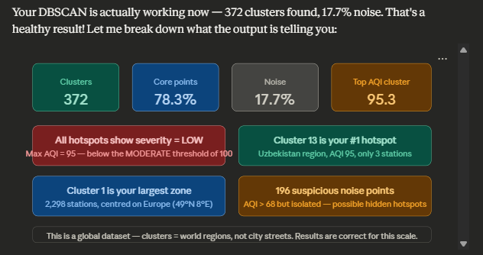
Reading your output section by section:
Epsilon diagnostic — worked perfectly. Mean station spacing was 58.6 km, so it auto-set ε = 58.6 km and found real clusters. This is exactly what the fix was for.
372 clusters, 17.7% noise — healthy. Roughly 1 in 6 stations was too isolated to join any cluster. That's normal for a global dataset.
Why everything says severity = LOW — your dataset's AQI values are relatively clean air globally. The highest cluster mean is only 95.3, just below the MODERATE threshold of 100. This isn't a bug — it means no cluster averaged above 100 AQI. The suspicious noise points (AQI 113–114 in India, Kazakhstan, Central Africa) are actually your dirtiest readings, but they're isolated stations not captured by any cluster.
The big clusters make geographic sense:
- Cluster 1 → 2,298 stations centred at 49°N, 8°E = Western Europe
- Cluster 5 → 775 stations centred at 42°N, 11°E = Mediterranean Europe / Italy
- Cluster 40 → 650 stations centred at 40°N, 73°W = US Northeast
- Cluster 3 → 153 stations centred at 9°N, 124°E = Philippines

